Flight reservatıon system

Project Planning

SELİN AKGÜN

201835008

Table of Contents

1.Introduction 2

2.Business Description 2

3.Job Workflow 2

4.Use Case Diagram 3

5.Project Layers 3

5.1. User Interface Layer 3

5.2. Business Logic Layer 5

5.3. Data Layer 5

6.Conclusion 7

# Introduction

In this report, the planning of the flight reservation system project is explained. Detailed information is given about the workflow, explanation, and project layers.

# Business Description

With the development of technology, the confidence in aircraft has increased over the years. This makes the planes safer and faster. It is frequently preferred for travel because it is no longer economically expensive. Airlines need software to track their flights. According to my research, the features they look for in these software are; Customer information, flight information, sold ticket information, turnover information and so on. In addition, large companies attach importance to data privacy, in this case data security will be of great importance for the project. When the project becomes operational, it will be used by airline company officials and will play a role in the realization of basic activities. They will support their customers by offering features such as ticket sales, sales cancellation and flight tracking. I will develop the project in C# programming language to run on Windows platform. I will use MsSQL as database because C# contains many libraries that can work with Mssql. I will make sure that the interface is user-friendly and dynamic, so that my customers can use it easily. I will ensure that company officials have access to all data through the admin panel.

# Job Workflow

When the application is operational, the first step will be the security phase. I will provide security with a password so that no access is allowed except for the authorities. Different types of personnel will have different authorizations in the system. While a pilot cannot view ticket information, he will be able to view his own flight information. The sales consultant will be able to view both flight and ticket information. Thanks to this type of user types, data security and consistency will be ensured. Customers will also be able to log in to the system and view their flight information. Sales consultants will have powers such as adding new customer records, adding flights, adding routes through the system. Also, of course, it will be able to sell and cancel tickets. There will be access to all tables in the admin panel, so that direct intervention can be made in an emergency.

# Use Case Diagram

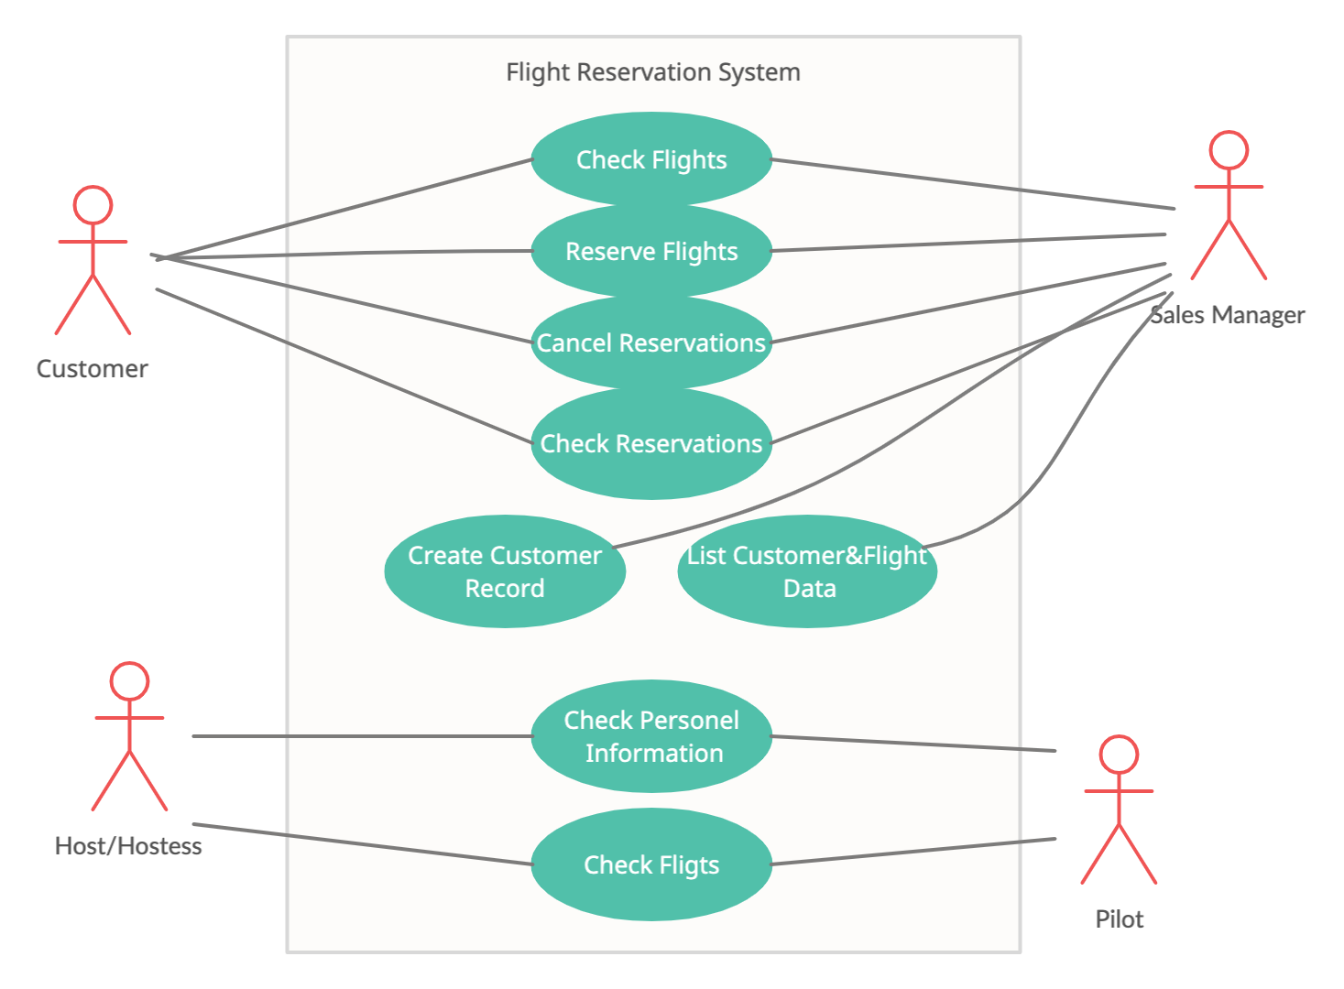

# Project Layers

## User Interface Layer

A basic sketch of user interface given below:

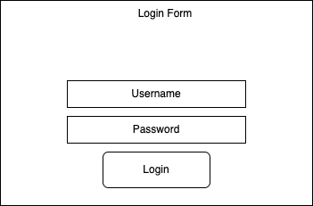

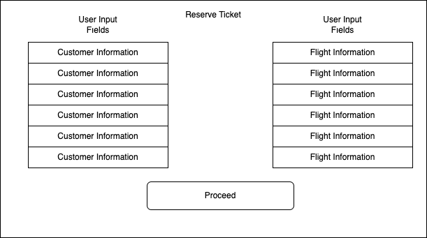

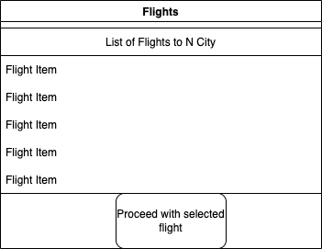

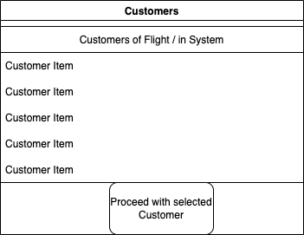

tablo içeren bir resim

Açıklama otomatik olarak oluşturuldu

## Business Logic Layer

Function Headers of Logical processes given below:

1. Buy Ticket
2. Cancel Reservation
3. Plan Flight
4. Cancel Flight
5. Add Customer Record
6. Delete Customer Record
7. Sell Ticket
8. List Flight Data
9. List Ticket Data
10. List Customer Data
11. List Employee Data
12. Add Employee Record
13. Remove Employee Record
14. And so on..

## Data Layer

In line with my research, I have accessed the data held by airline companies about structures such as passengers, planes, flights, tickets. These structures and their possible probable data are given below under headings.

1. Customer
   1. Identity
   2. Name&Surname
   3. Contact Number
   4. Address
   5. Date of Birth
   6. Gender
2. Employee
   1. Identity
   2. Name&Surname
   3. Wage
   4. Contact Number
   5. Address
   6. Date of Birth
   7. Gender
   8. Job
3. Airplane
   1. Model
   2. Type
4. Airplane Cost
   1. Airplane
   2. Cost Type
   3. Date
   4. Cost
5. Flight
   1. Airplane
   2. Date
   3. Time
   4. Flight Code
   5. Capacity
   6. Departure
   7. Arrival

More structures are going to be in database according to needs of application.

# Conclusion

I aim to complete the project by establishing a connection between the interface I will create in line with my plans and the database, performing error checks and performing various tests. The contents described in this report are the project plan, and additional features will be added during my work.